

Practices for Secure Software Report

Table of Contents
Document Revision History 3
Client 3
Instructions 3
Developer 4
1. Algorithm Cipher 4
2. Certificate Generation 4
3. Deploy Cipher 4
4. Secure Communications 4
5. Secondary Testing 4
6. Functional Testing 4
7. Summary 4
8. Industry Standard Best Practices 4

Document Revision History

Version | Date | Author | Comments
1.0 | 8/14/24 | Jaiden Blanchard

Client



Instructions

Submit this completed practices for secure software report. Replace the bracketed text with the relevant information. You must document your process for writing secure communications and refactoring code that complies with software security testing protocols.

- Respond to the steps outlined below and include your findings.
- Respond using your own words. You may also choose to include images or supporting materials. If you include them, make certain to insert them in all the relevant locations in the document.
- Refer to the Project Two Guidelines and Rubric for more detailed instructions about each section of the template.

Developer
Jaiden Blanchard

Algorithm Cipher

Because Artemis Financial is an online banking web application that transfers information via the Internet, my recommended cipher is SHA-256. SHA-256 is a symmetrical encryption cipher that generates unique hash values for all inputs. SHA-256 makes use of an avalanche effect, where changing a minute detail of the stored data will then change the hash values of all stored data. SHA-256 is also incredibly invulnerable to brute-force attacks, which is perfect for Artemis Financial because the transfer of data will be more secure for its users. SHA-256 is one of the standards for banking applications especially since no one has managed to crack it before.

SHA-256 creates a 256-bit hash value out of any length of data, this means that large amounts of data and small amounts of data would all be stored in a fixed length making the information more secure. SHA-256 has a 32-bit level, and its alternate version SHA-512 has a 64-bit level. SHA-512 is more secure than SHA-256 since a higher bit level means a more difficult code to crack but often that level of bit can be overkill.

SHA-256 is a symmetric cipher, which means it has one key for encrypting and decrypting all stored data. A non-symmetric cipher would have a key for encrypting and a key for decrypting all stored data. As a rule of thumb, most non-symmetric ciphers are considered safer, but they often work slower than symmetric ciphers and can be more difficult to use.

A cipher that generates random numbers such as SHA-256 means that the decryption and encryption key is very difficult to guess, and resistant to brute force by both humans and machines.

Humans have used encryption for most of history. Many people from different races, cultures, and backgrounds have made use of encryption for many different reasons. Even in famous cases like the Zodiac Killer, Voynich Manuscript, and the Kryptos statue, encryption can continue to hide information even when the encrypted cipher can be studied by people throughout the globe. While in these cases it was often humans writing their own encryption ciphers, Modern-day encryption algorithms make use of mathematics to automatically encrypt and decrypt data for transfer and storage. Encryption is not something that will die out, instead, it will only become more advanced as new methods and techniques are discovered and invented.

Certificate Generation

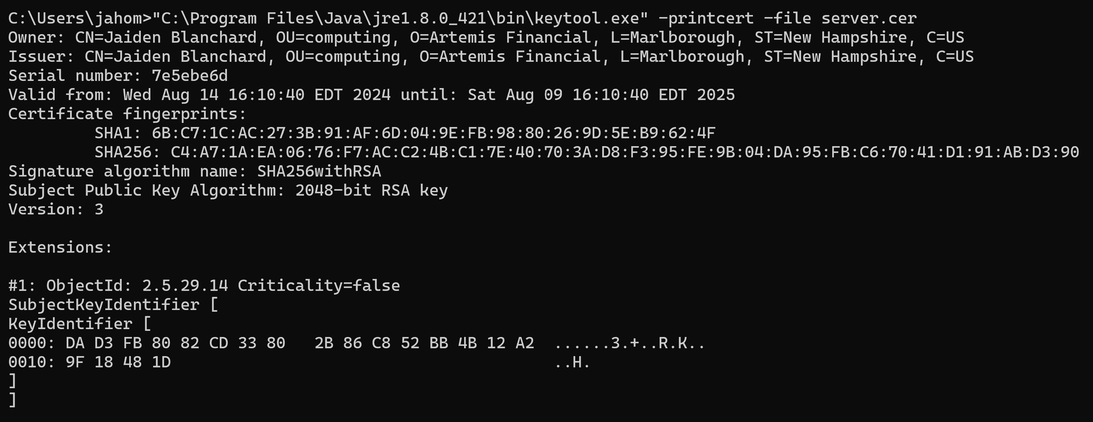

Deploy Cipher
Insert a screenshot below of the checksum verification.

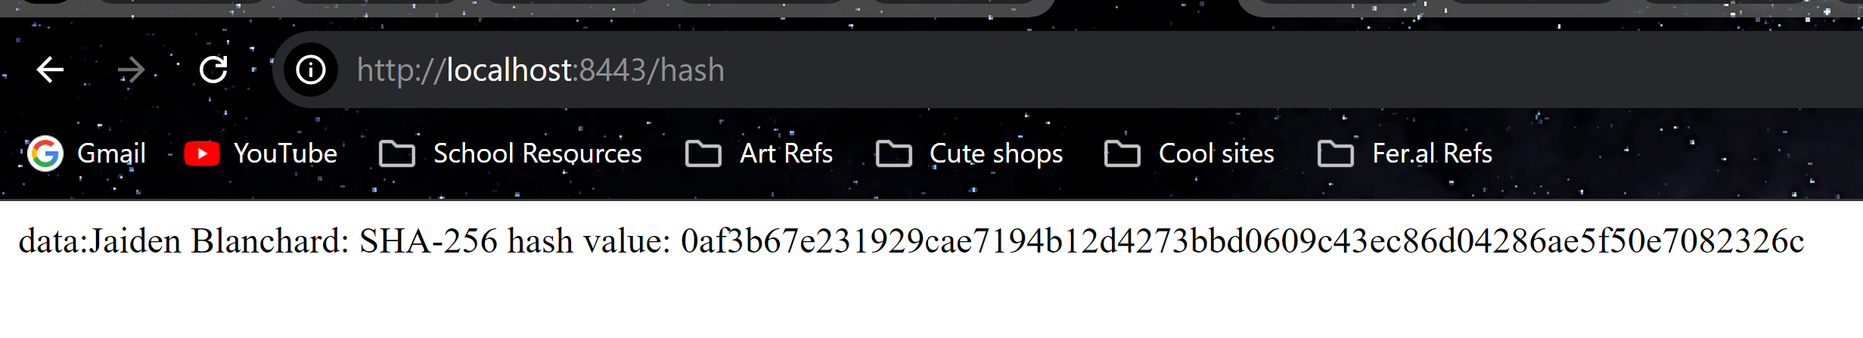

Secure Communications
Insert a screenshot below of the web browser that shows a secure webpage.

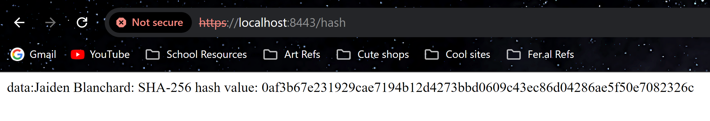

Secondary Testing
Insert screenshots below of the refactored code executed without errors and the dependency-check report.

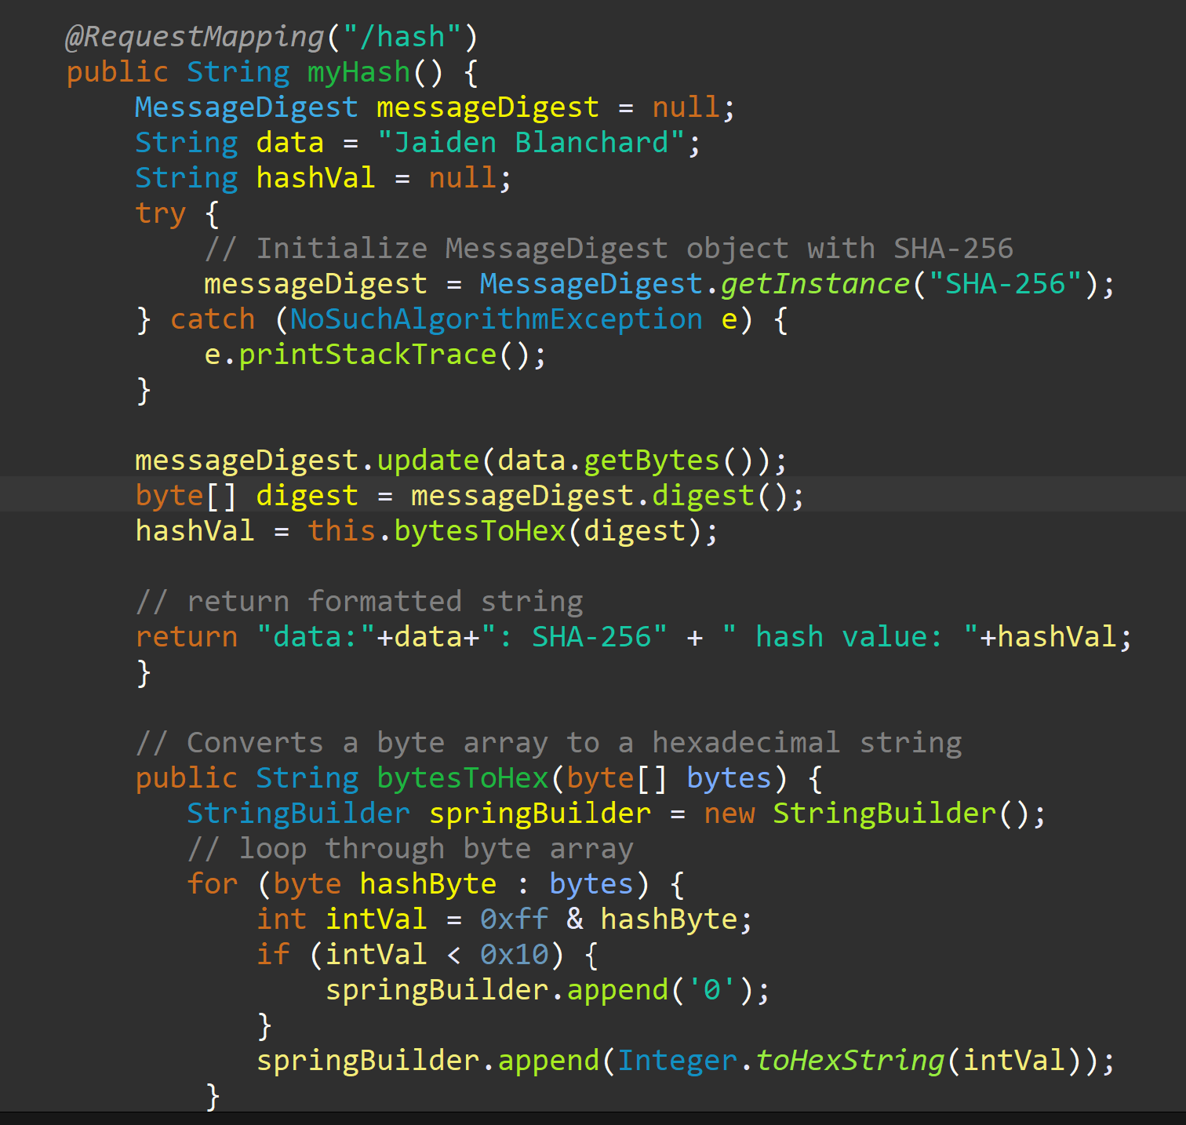

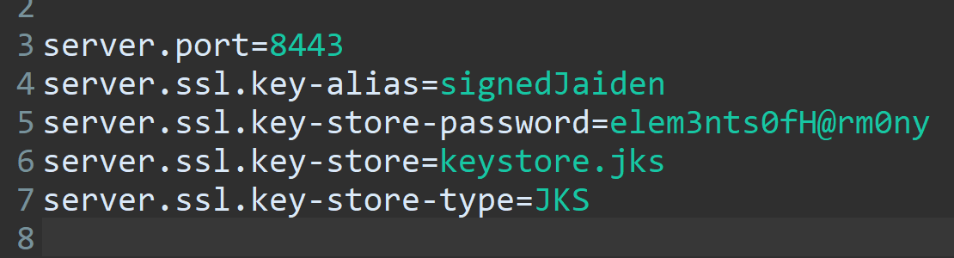

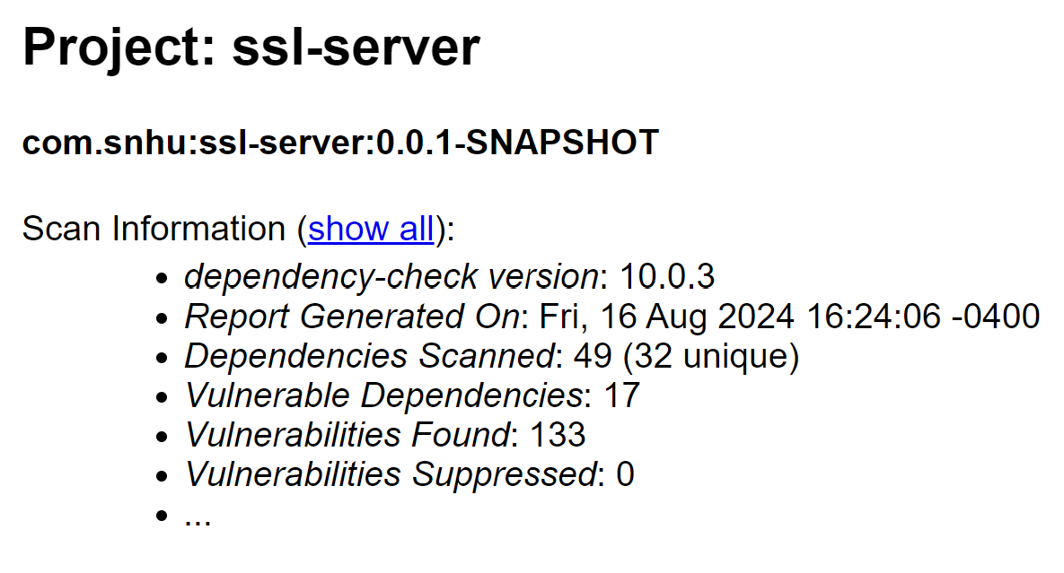

file:///C:/Users/jahom/Documents/college/software%20security/CS%20305%20Project%20Two%20Code%20Base/ssl-server_student/target/dependency-check-report.html

I ran a dependency check before deploying my cipher and they both look the same which I assume means I did not introduce any extra vulnerabilities. If I am misunderstanding this, please let me know.

Functional Testing
Insert a screenshot below of the refactored code executed without errors.

The only part of the code that I refactored was updating the maven dependency from version 5.3.0 to version 10.0.3. I do know that the version of Java that this was made in is out of date. However, every time I try to update the file something breaks. I’m also aware that the current spring framework is 3.3.2 but again, every time I try to fix it something breaks.

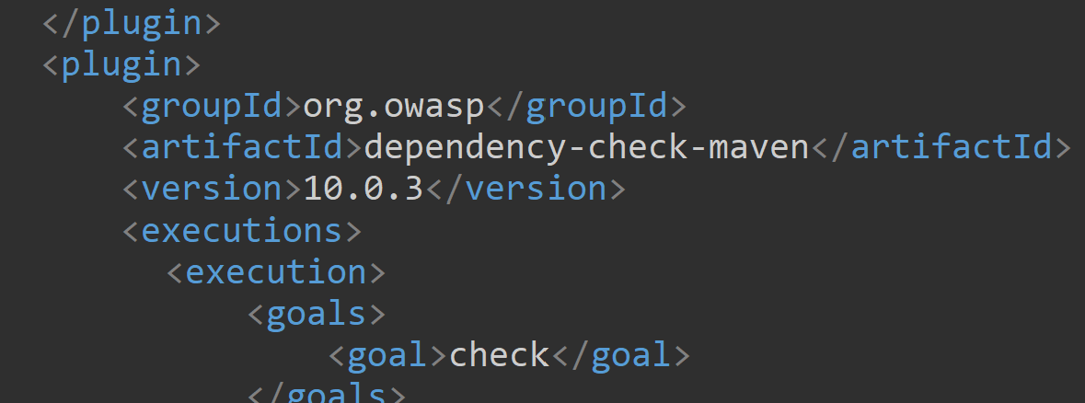

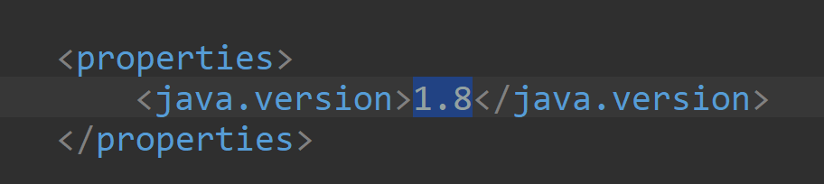

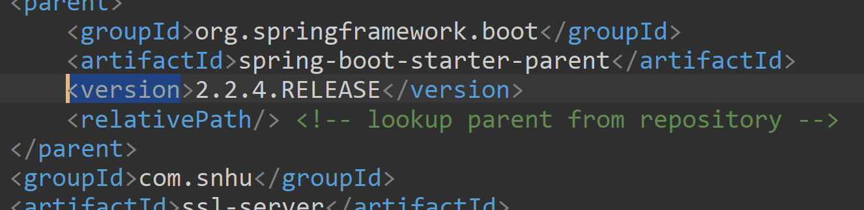

Summary

The areas of security I addressed by refactoring the code (or at least pointing out that they need to be refactored) include cryptography, code quality, data access, client/server, and plug-ins. My process for adding layers of security to software applications starts by analyzing the current plugins/outside sources for updates and more recent versions so the security is at its current peak. Then I assess the code for input/error handling to ensure that commands and prompts cannot be abused or broken by users of the system. Lastly, I also review the Maven Dependency check for anything that might catch my eye or that appears new or fixable.

Industry Standard Best Practices

I used industry-standard best practices to maintain the applications existing security by making use of HTTPS, which is a requirement for many secure websites nowadays, and generating a CA which all secure websites obtain at some point, even if mine isn’t technically “approved” yet. I also made use of a highly recommended cipher for my application, SHA-256, so that data being stored in the software would be safely encrypted. Finally, I used existing secure plugins that monitor for dependencies and vulnerabilities and ensured those plugins were up to date.

Applying industry standard best practices is important for the company’s overall well-being because it mitigates the chances of security breaches and data leaks. It also ensures that customers, patrons, and users of the software have a safe and secure experience. Industry-standard best practices are usually the most secure protocols that developers can use in their programs and many companies that don’t make use of them often don’t make it far in the corporate world due to the vast amounts of cybersecurity attacks.

